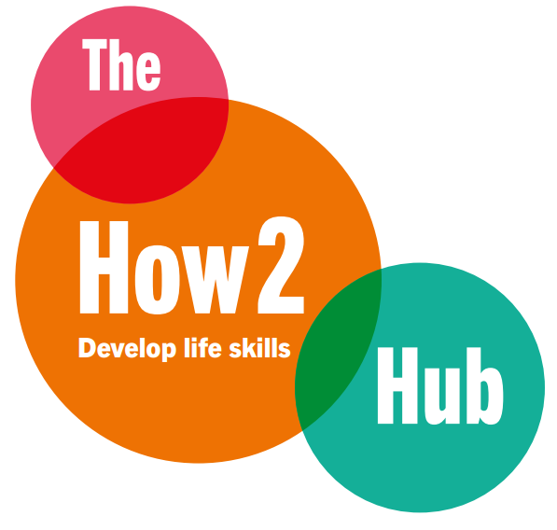

The How2Hub – Current Activity Overview
We are currently working in collaboration with schools through delivery of the Monday Club pilot, supporting small groups of pupils with structured, engagement-led sessions linked to real workplace experiences.
Alongside this, we are working with a university partner where students are contributing to the live build of the platform as part of their course, gaining real-world project experience while helping develop core functionality.
In parallel, further education college students are producing short, three-minute employer films, creating a growing library of accessible, student-led content showcasing local industries and career pathways.
Our approach is aligned with the Careers & Enterprise Company framework and Gatsby Benchmarks, and is being shaped in line with the 2026 UK Education White Paper, particularly around measurable experience, inclusion and earlier exposure to work.
The platform is currently being developed on a pro bono basis through these education partnerships, allowing us to test, refine and evidence the model in real-world settings while maintaining low early-stage cost and strong delivery focus.

